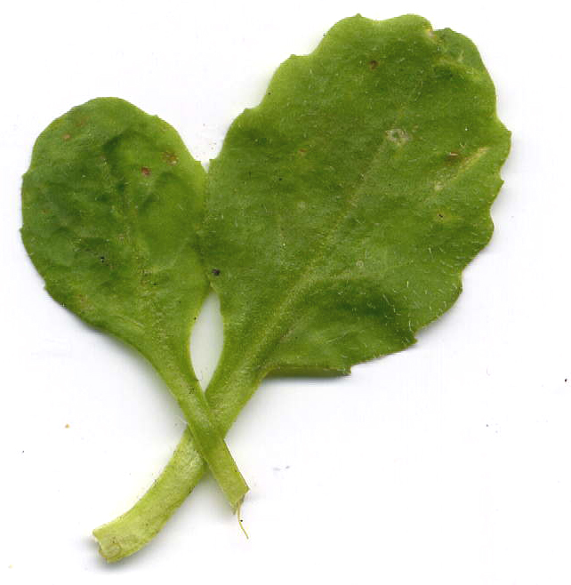
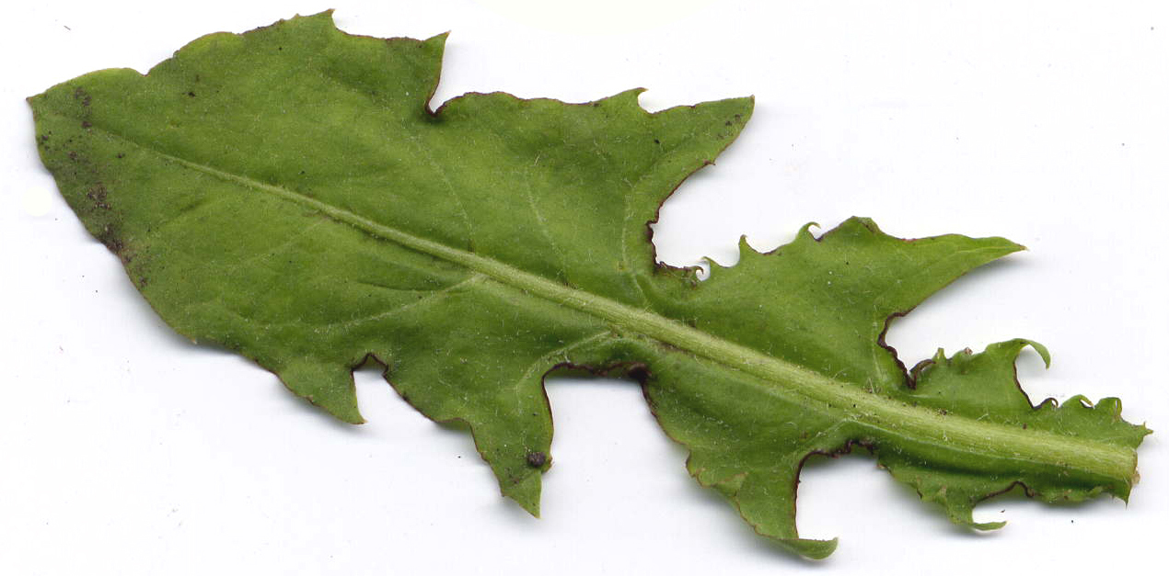
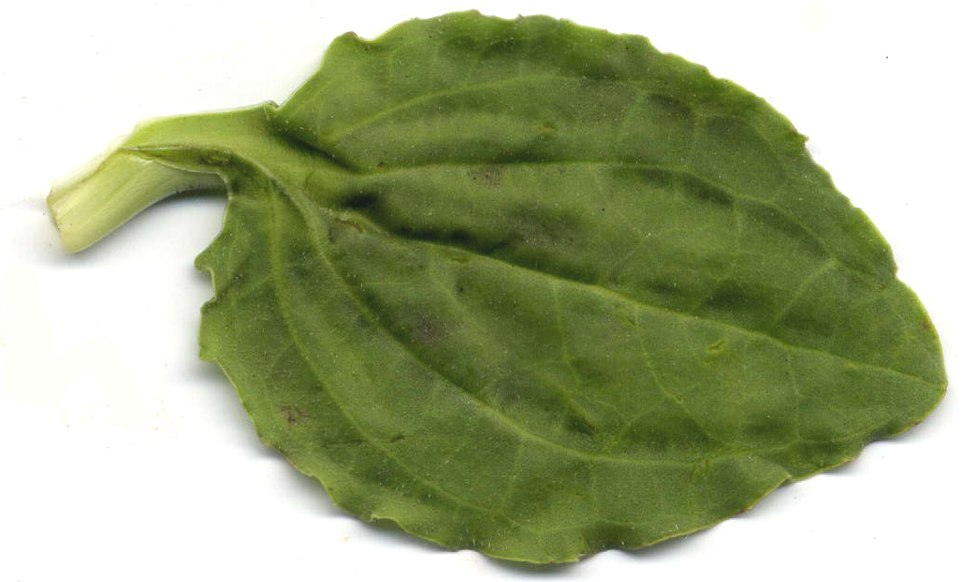
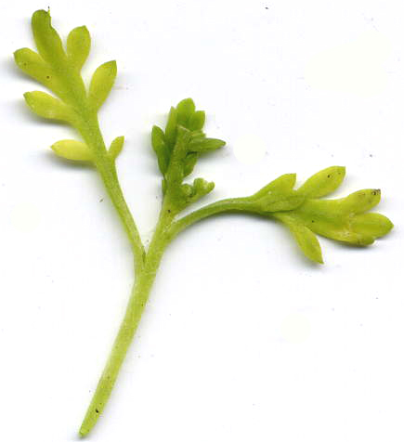
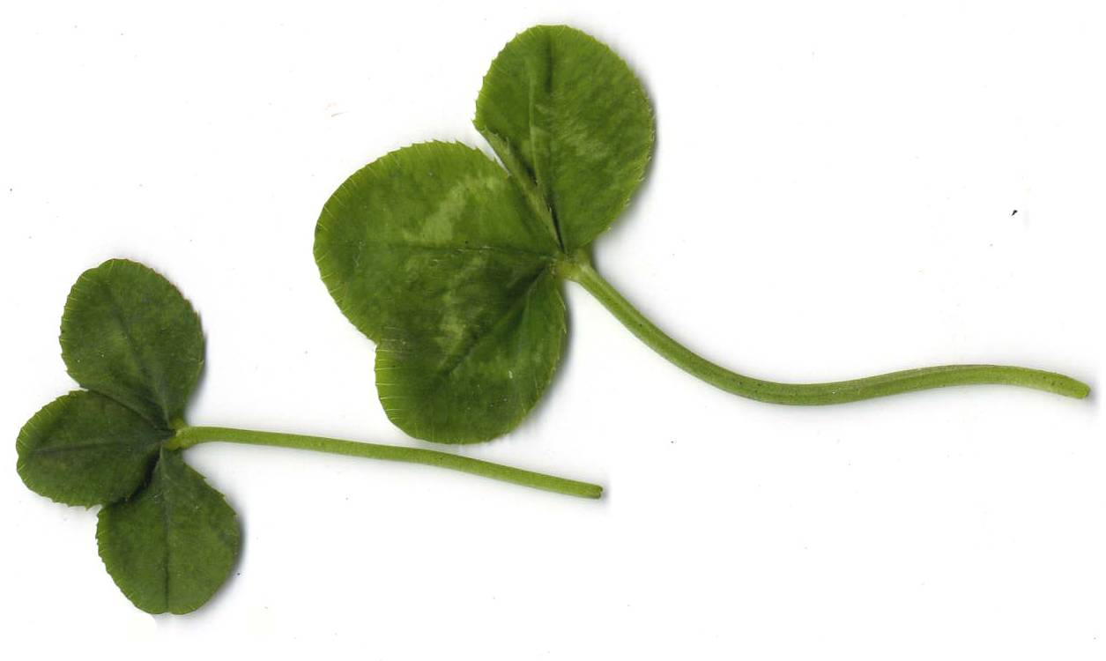
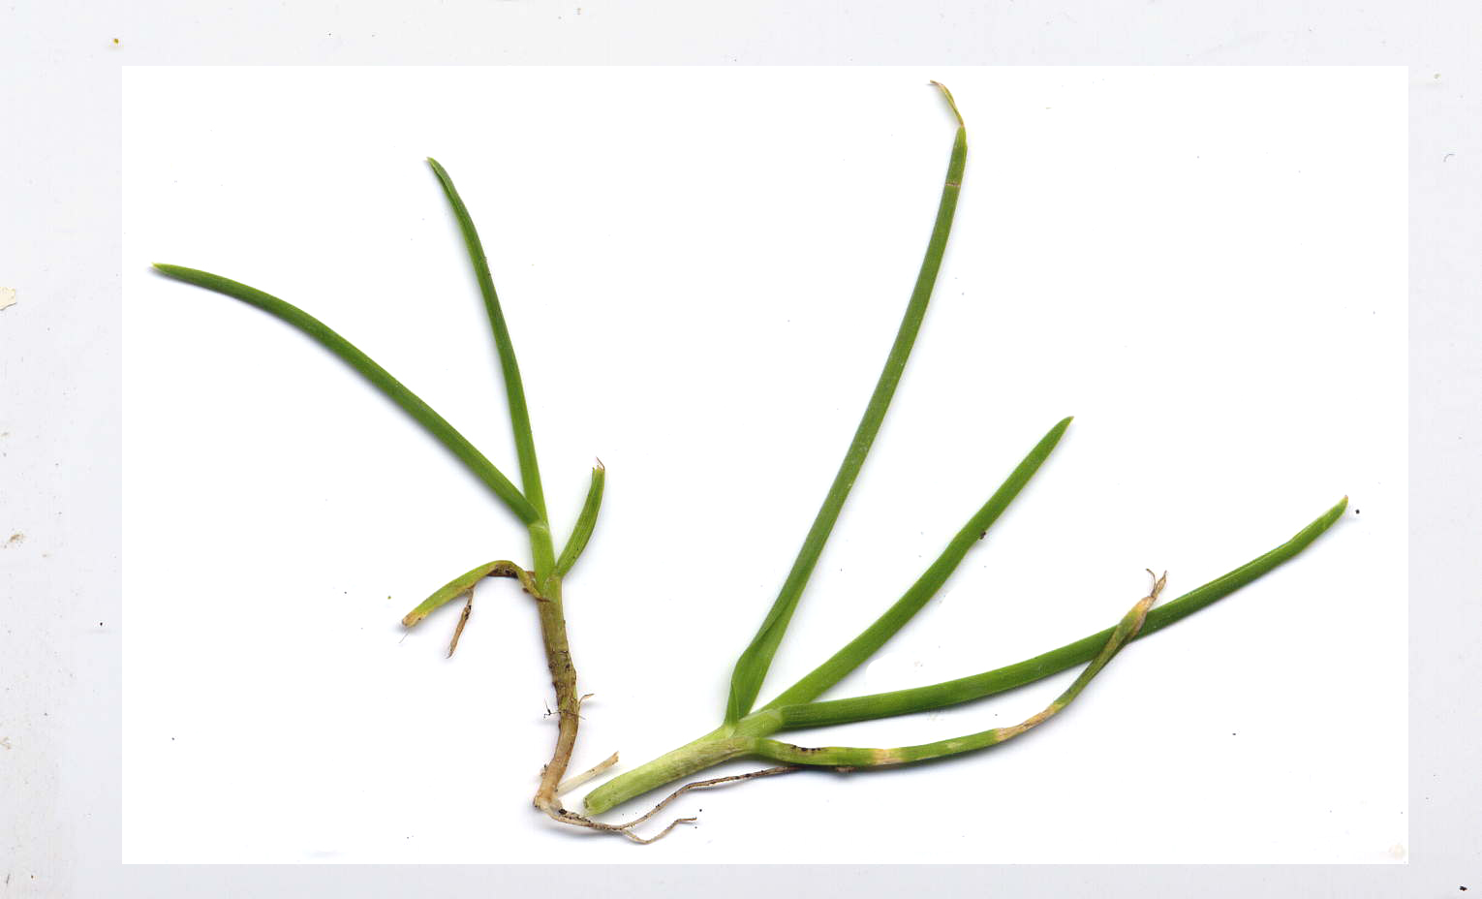
Lawn survey - Identification and recording table 1 - Density
Scan of plant | Name | No. of plants
Daisy
Bellis perennis
Dandelion
Taraxacum section Ruderale
Lesser Swine-cress
Coronopus didymus
Greater Plantain
Plantago major
White Clover
Trifolium repens
Perennial Rye-grass
Lolium perenne
For each species count the number of plants

